Foundation Subject | Key Strands to the Curriculum: | Curriculum coverage
PSHE & HRE | 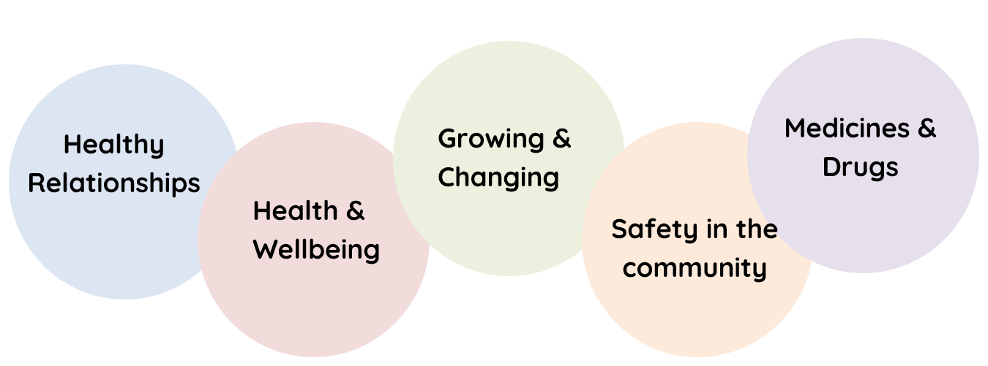 | - PSHE & HRE Scheme of work  - British Values  - School Council  - Eco Council  - Playground Buddies (Anti-Bullying)  - Assemblies  - SHINE  - ELSA  - Trauma Informed UK  - Behaviour Curriculum  - Talk through Stories  - Positive Playgrounds  - COVID Recovery Curriculum  - Interventions 1:1 and small group  - Links with external services eg NSPCC  - Computing Curriculum
Art & Design | 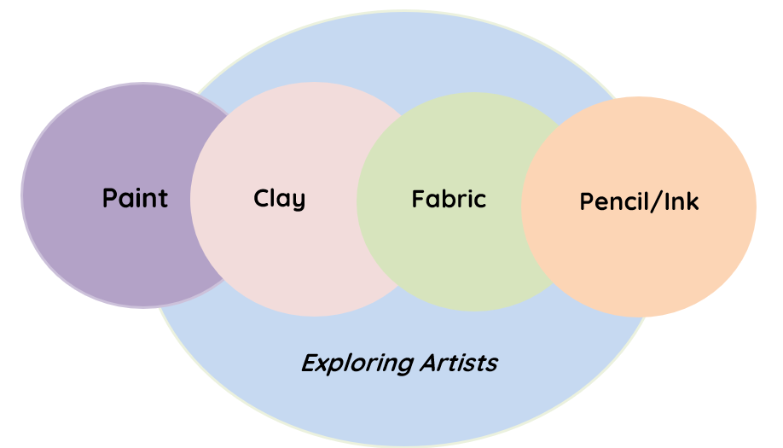 | - Art Scheme of work  - Local Authority ‘Picture This’ project
Music | 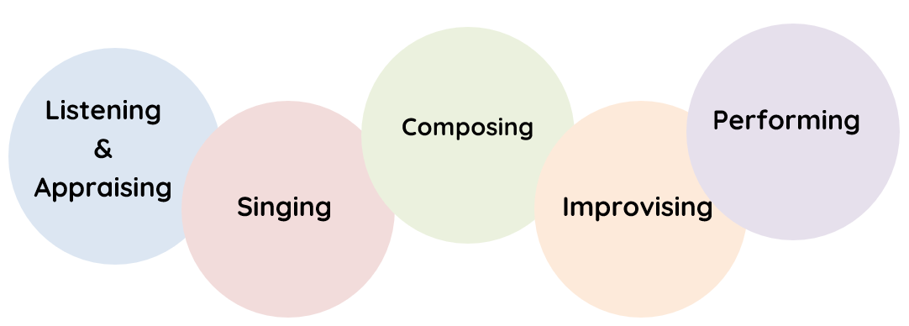 | - Charanga scheme of work  - Assemblies  - Singing Practise  - Music exposure whilst getting changed to music  - Recorder Club
PE | 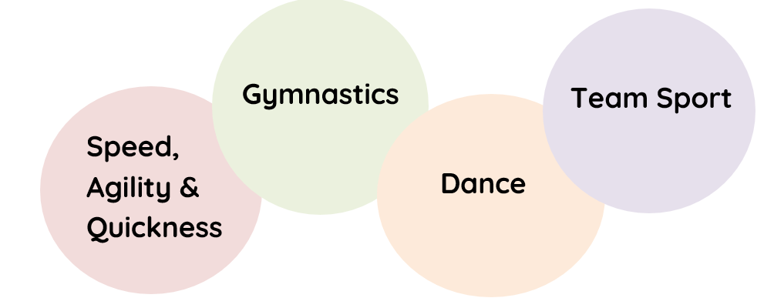 | - Live & Learn Sports  - PE scheme of work  - Active Playgrounds  - Competitions in school & with local schools  - Annual sports day event  - SHINE/ Parent/child workshops
RE | 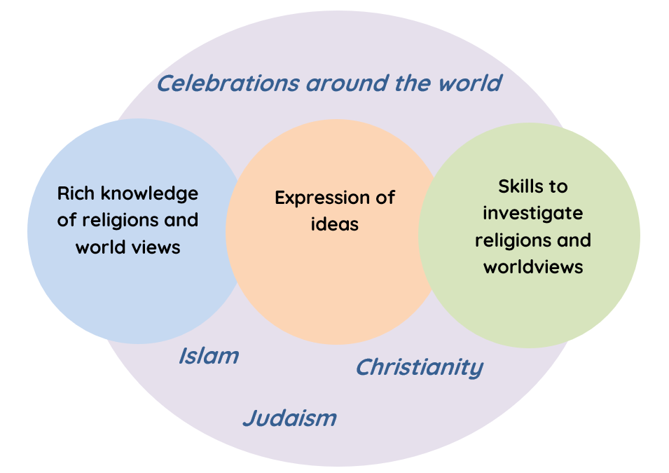 | - RE Scheme of work  - Assemblies  - School celebration events; Christmas, Eid, Chinese New Year, Diwali  - Talk through Stories  - School Council
Science | 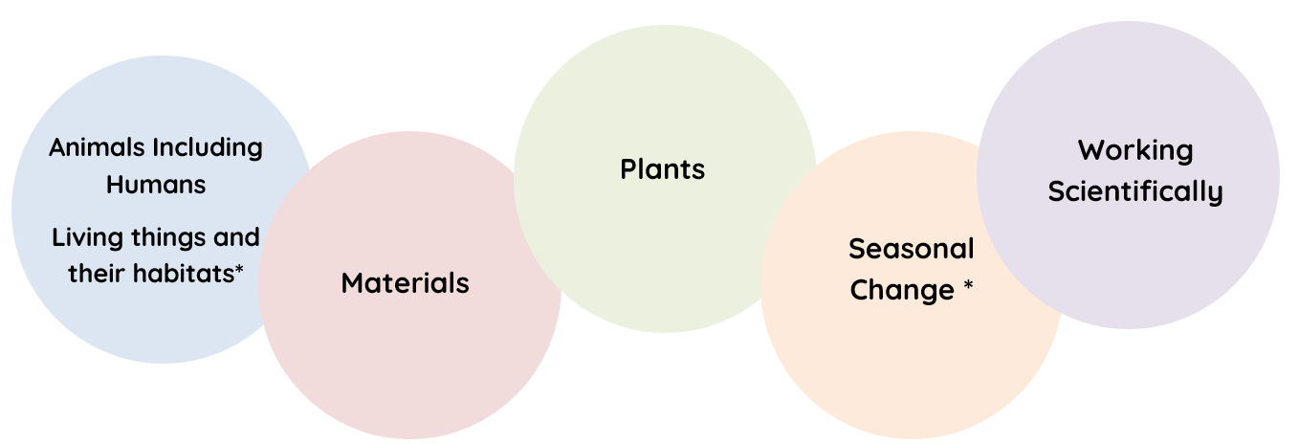 | - Science scheme of work  - STEM Challenges  - Science Weeks  - Parent/child workshops  - Use of the school grounds; forest, beach, pond area
Design & Technology | 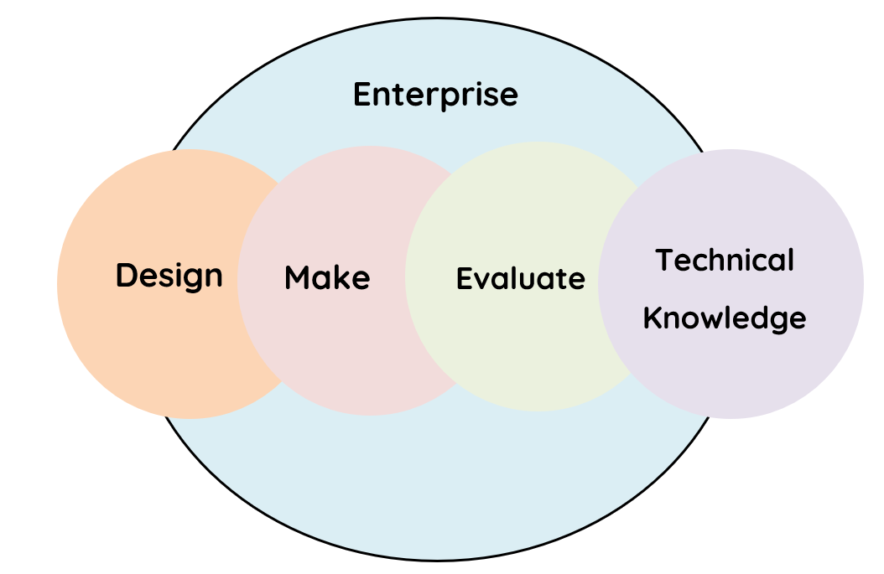 | - DT scheme of work  - Enterprise Curriculum  - Parent/child workshops  - Links with external businesses
Geography | 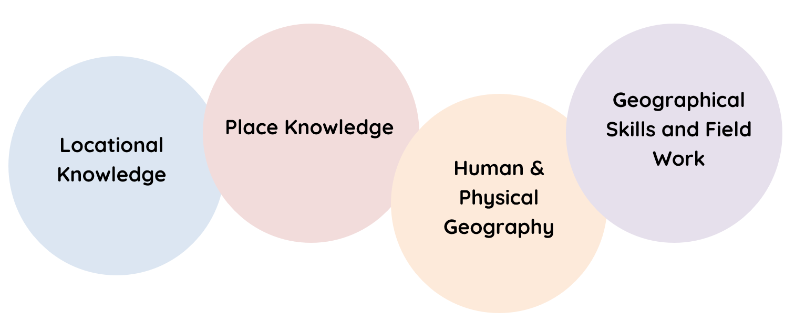 | - Geography scheme of work  - Eco Council  - Grey to Green Club  - Local Walks  - Use of the school grounds; forest, beach, pond area
History | 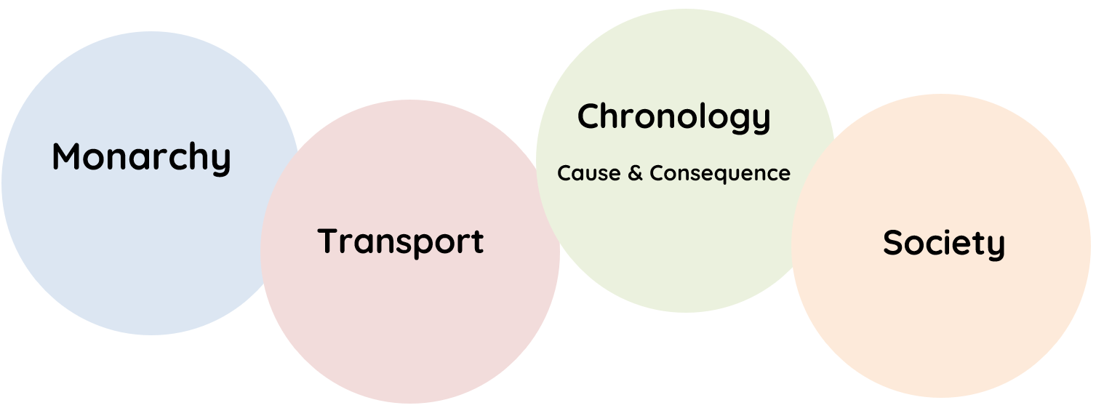 | - History Scheme of work  - Assemblies  - Classroom Timelines  - British Values
Computing | 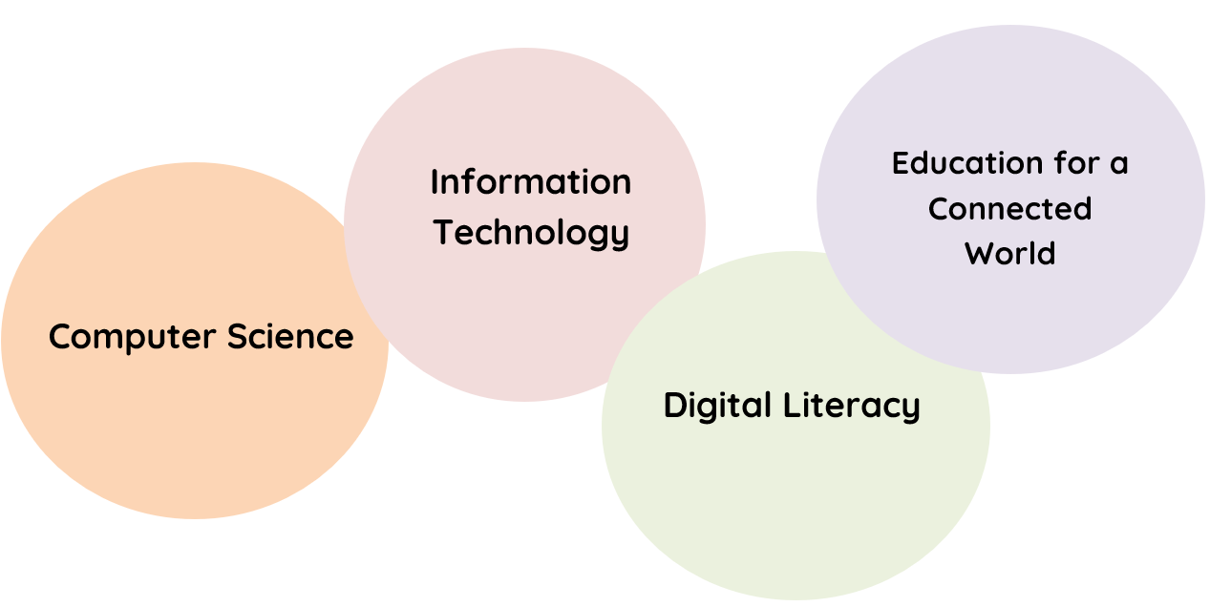 | - Computing sequence of work  - PSHE/HRE scheme of work  - Assemblies  - E-safety week

