Learning Objective: (Taken from SOW)  To recognise their own growing competencies and responsibilities. | Key Questions/Concepts:  How do people know I’m growing?  What new things can I do | Key Vocabulary  - Change  - Discover  - Evidence  - Family  - Food  - Growing Up  - Love  - People  - Places  - Recognise  - Remember  - Responsible  - Shape  - Size  - Skills  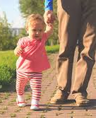  - Visit | Resources  Time line  Images  Pictures/Photographs  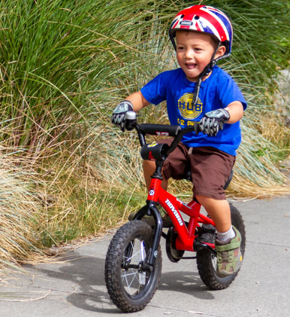  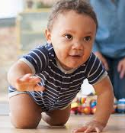
Children to bring in pictures of themselves as babies or toddlers. Teacher to display these around the classroom. Children to discuss how they have physically changed (e.g. more hair, more teeth, taller, bigger hands/feet)
Children to think about and discuss what they can do now, that they could not do before (e.g. walk, talk, write, ride a bike, run)

Ask the children what age do you think you:
-walked
-talked
-go to school
-ride a bike/scooter

Ask the children what age will you be able to:
-Ride a bike/scooter
-Play out on my own
- Walk to school by myself
-Drive a car
-Get a job

Children share ideas and create a timeline of these events.

