Learning Objective: (Taken from SOW)  That others’ families, either in school or in the wider world, sometimes look different from their family, but that they should respect those differences and know that other children’s families are also characterised by love and care. | Key Questions/Concepts:  How are families different? | Key Vocabulary  - Alike  - Different  - Feelings  - Friendship  - Fun  - Kind  - Network  - Positive  - Same  - Same as  - Share  - Special  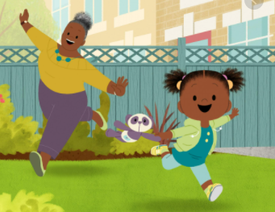  - Love | Resources  We are family by Patrica Hegarty  Images of Peppa Pig, The Gruffalo  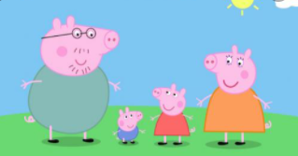  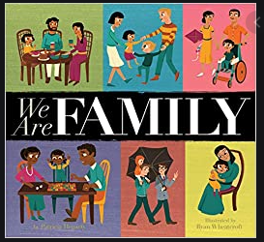
Explore different families through familiar characters e.g. Peppa Pig – traditional family, The Gruffalo – single family, 2 mummies and 2 daddies. Display images of these and discuss how these families are different and the same.

Share ‘We are Family’. Children to listen and then discuss the family and how they may be similar/different to their family.

Teacher to explain that even though these families may be different there are still fundamental values which make all these families the same. Can the children think what these might be? Love, care, respect, safety.

Children to draw a picture of their family. Once they have drawn their picture Teacher display these pictures around the classroom and children to look for similarities and differences.



