Learning Objective: (Taken from SOW)  How to recognise and talk about their emotions, including having a varied vocabulary of words to use when talking about their own and others’ feelings. | Key Questions/Concepts:  What are emotions? | Key Vocabulary  - Angry  - Anxious  - Embarrassed (etc.)  - Excited  - Happy  - Lonely  - Relax  - Sad  - Scared  - Stress | Resources  Emotion picture cards  Music clips  Book: How are you feeling today?  By Mollie Porter  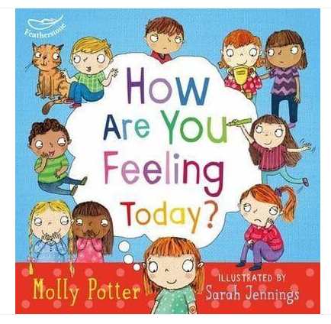
Share ‘How are you feeling today’ by Mollie Porter.

Explore the different types of emotions – use picture cards of each emotion to prompt discussions.

Ask: How are they feeling? Why might they be feeling this way? Children to discuss their ideas and share with the rest of the class.

Teacher read out a scenario. Children to have a blank face template and playdoh. Using playdough children to make the face to show the emotion that the scenario might make somebody feel. Children discuss the faces they have made and the emotion it represents.

Learning Objective: (Taken from SOW)  How to recognise and talk about their emotions, including having a varied vocabulary of words to use when talking about their own and others’ feelings. | Key Questions/Concepts:  What are emotions? | Key Vocabulary  - Angry  - Anxious  - Embarrassed (etc.)  - Excited  - Happy  - Lonely  - Relax  - Sad  - Scared  - Stress | Resources  Music Clips  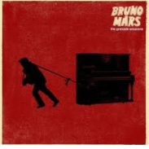  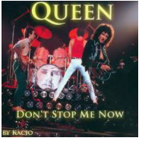
Identify the names of different emotions – explore language using key vocabulary

Listen to music e.g. Bruno Mars – You are beautiful, Queen – Don’t Stop me Now, Halloween – spooky music, Beatles – Get by with a Little Help from my Friends.

Discuss the emotions that the children experienced, can they link them to some of their own life experiences? From the music played children to choose which music would be them happy, make them feel powerful, run faster. Finally can music affect the way that we feel?

The Department for Education have released a sample mental health lesson for Year 1, if you wish to view this, please use the link below:
https://watch.cloudflarestream.com/2b4c69d78c4825edb79228d679b9961c


