
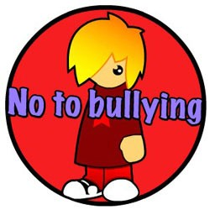

Pupil Friendly
Anti-Bullying Policy

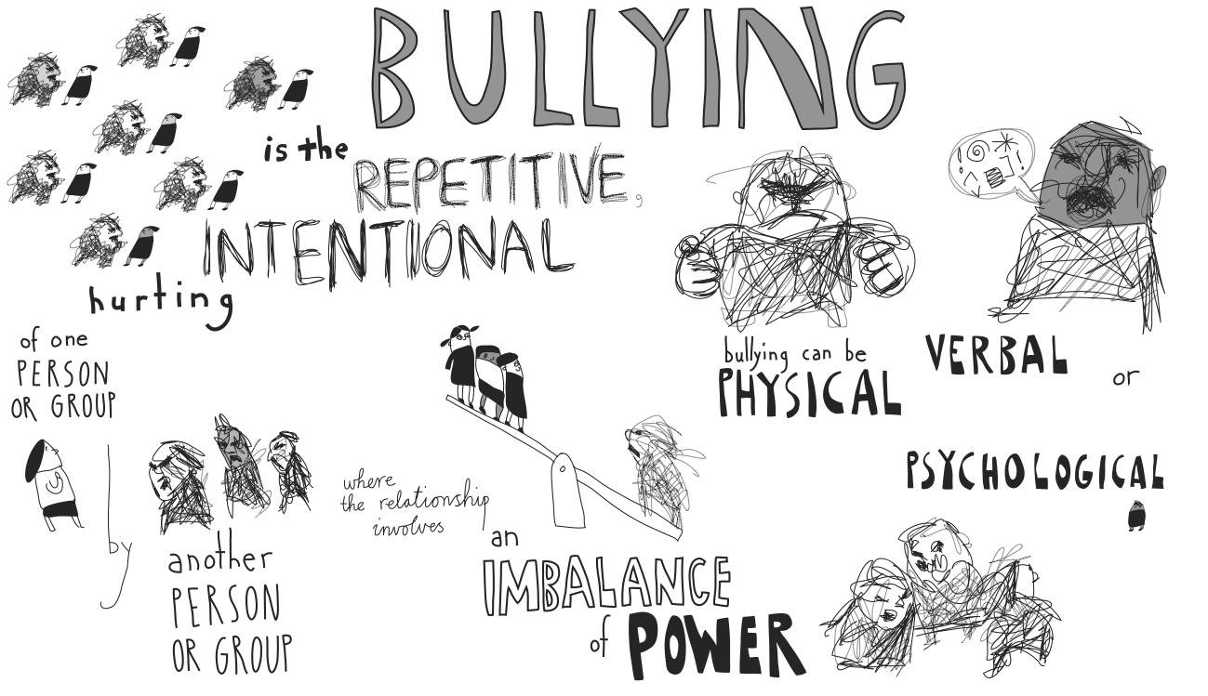
If you are bullied: -

DO: -
- Ask them to STOP if you can.
- Use eye contact and tell them to go away.
- Ignore them.
- Walk away.
- Talk to a friend.
- TELL SOMEONE.

DON’T: -
- Do what they say.
- Get angry or look upset.
- Hit them.
- Think it’s your fault.
- Hide it.
What should I do if I see someone else is being bullied?

- Tell an adult straight away.
- Don’t try and get involved – you might end up getting hurt or you could end up in trouble yourself.
- Don’t stay silent or the bullying will keep happening

The Head, the Governors and the staff will work together to: -
- Make our school a place where everyone can feel safe and happy. That means no bullying allowed.
- We will help everyone to get on with each other and we believe that everyone has the right to be who they are.

What will happen to a bully? Teachers will get involved and help you solve problems. They can give out yellow and red cards, talk to your parents and talk to your friends.



Bullying Can be……
When is it bullying?

everal Times On
urpose

We promise to always treat bullying seriously.
S
P
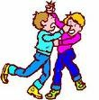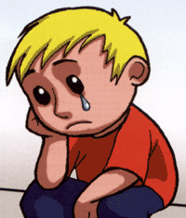
What is Bullying?

A bully is someone who hurts someone else by using behaviour which is meant to hurt, frighten or upset another person. This behaviour is repeated many times.

Emotional: Hurting people’s feelings, leaving you out.
Physical: Punching, kicking, spitting hitting, pushing.
Verbal: Being teased, name calling. Cyber: saying unkind things by text, e- mail and online.
Racist: calling you names because of the colour of your skin.
Who can I tell?

A Friend Parents/Carers Teachers School Buddies
Lunch time Staff Any Other Adult
MOST IMPORTANTLY: -

If you are being bullied:

Start Telling Other People!

